Name : Maiyani Gautam Sureshbhai
Branch : CSE
Sub : DBMS
Seat No : 312025
Batch : Y-batch
Prn : 2020033800100853
E-mail : gautammaiyani2332@gmail.com
Mob. No: 9067548332
SUPPLIER(SID, SNAME, CITY)
PART(PID, PNAME, COLOR)
CATALOG(SID, PID, COST)

- Create the above tables with necessary constraints.

create table supplier(

sid int primary key not null,
sname varchar(15) not null,
city varchar(15) not null
);
desc supplier
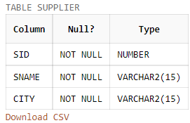

create table part(
pid int primary key,
pname varchar(20) not null,
color varchar(20) not null
);
desc part
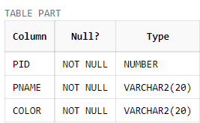

create table catalog(

sid int not null,
pid int not null,
cost int not null,
constraint fk_sid primary key(sid,pid),
foreign key(sid) references Supplier(sid) delete on cascade,
foreign key(pid) references Part(pid) delete on cascade
);
desc catalog
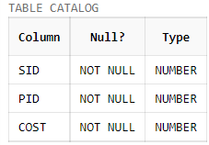

- Inserting Values Into the Table..

insert into supplier(sid,sname,city) values(1,'Raj','Mumbai');
insert into supplier(sid,sname,city) values(2,'Joy','Delhi');
insert into supplier(sid,sname,city) values(3,'Rajdeep','Mumbai');
insert into supplier(sid,sname,city) values(4,'Andrew','Up');
insert into supplier(sid,sname,city) values(5,'Jason','Kolkata');
insert into supplier(sid,sname,city) values(6,'Root','Surat');

select * from supplier;

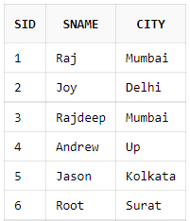

insert into part(pid,pname,color) values(10,'p-1','Red');
insert into part(pid,pname,color) values(20,'p-2','Blue');
insert into part(pid,pname,color) values(30,'p-3','Red');
insert into part(pid,pname,color) values(40,'p-4','Green');
insert into part(pid,pname,color) values(50,'p-5','Yellow');

select * from part;

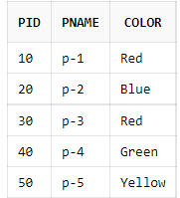

insert into catalog(sid,pid,cost) values(1,10,200);
insert into catalog(sid,pid,cost) values(2,10,350);
insert into catalog(sid,pid,cost) values(1,20,100);
insert into catalog(sid,pid,cost) values(3,30,1000);
insert into catalog(sid,pid,cost) values(3,10,200);
insert into catalog(sid,pid,cost) values(4,50,20);
insert into catalog(sid,pid,cost) values(2,50,600);
insert into catalog(sid,pid,cost) values(5,40,400);
insert into catalog(sid,pid,cost) values(5,20,2000);
insert into catalog(sid,pid,cost) values(1,30,500);
insert into catalog(sid,pid,cost) values(1,40,70);
insert into catalog(sid,pid,cost) values(2,20,170);
insert into catalog(sid,pid,cost) values(2,30,300);

select * from catalog;

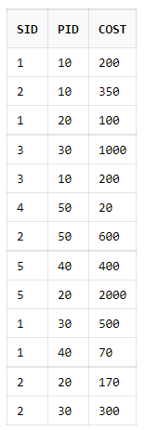

- Display details of suppliers who supply red colored parts.

select * from supplier
where sid in
(select distinct(sid) from catalog where pid in
(select pid from part where color='Red'));

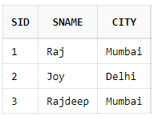

- Display total number of suppliers for each part.

select pid,count(*) from catalog group by pid;

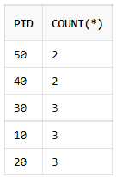

- Display suppliers based in Mumbai and whose names have ‘j’ as the third character.

select * from supplier
where upper(city)='MUMBAI' and upper(sname) like '__J%';
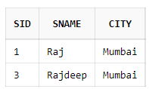

- Add a column SCONTACT to the table SUPPLIER which always has ‘0’(zero) as the first character.

alter table supplier add scontact number(10)constraint ck_count check(scontact like '0%');

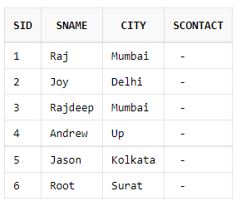

- Create a composite index on table SUPPLIER for the columns SNAME and CITY.

create index idx on supplier (sname,city);



- Display all those suppliers who supply more than three parts.

select sid from catalog group by sid having count(*)>3;

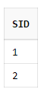

- Display suppliers who are not supplying any part.

select * from supplier where sid not in(select distinct(sid)from catalog);

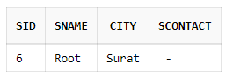

- Display the average cost of all green parts.

select avg(cost) from catalog where pid in(select pid from part where upper(color)='GREEN');

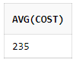

PART-B

CATEGORY(CAT_NO, CAT_TYPE, EXPIRY_DT)

ITEM (ITEMNO, IDESC, UNIT_OF_MEASURE, QTY_ON_HAND, WEIGHT, CAT_NO)

- Create the above tables with necessary constraints.

create table Category(

cat_no int constraint pk_cat_no primary key not null,
cat_type varchar(20) not null,
expiry_date date not null
);
desc Category

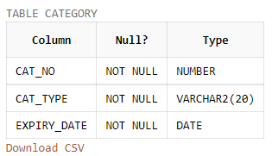

create table Item(

itemno int constraint pk_item_no primary key not null,
idesc varchar(10) not null,
unit_of_measure varchar(15) not null,
qty_on_hand int not null,
weight int not null,
cat_no constraint fk_cat_no references Category(cat_no)
);
desc Item

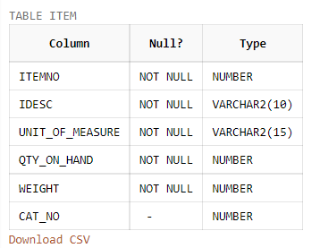

- Inserting values into the table

insert into Category values(1,'Dairyfood','1-NOV-2023');
insert into Category values(2,'Meat','25-JULY-2022');
insert into Category values(3,'Factory prod.','17-APR-2023');
insert into Category values(4,'Seafood','4-DEC-2022');
insert into Category values(5,'Fastfood','25-DEC-2023');

select * from Category;

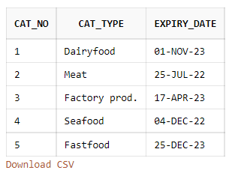

insert into Item values(111,'Tea','Kilograms',300,50,3);
insert into Item values(112,'Fish','Kilograms',20,10,4);
insert into Item values(113,'Milk','Liters',100,50,1);
insert into Item values(114,'Noodles','Kilograms',5,10,5);
insert into Item values(115,'Prep.Meat','Kilograms',25,20,2);
insert into Item values(116,'Coffee','Kilograms',35,50,3);
insert into Item values(117,'Pizza','Grams',30,200,5);
insert into Item values(118,'Cheese','Kilograms',150,1,1);
insert into Item values(119,'Curd','Liters',28,2,1);

select * from Item;

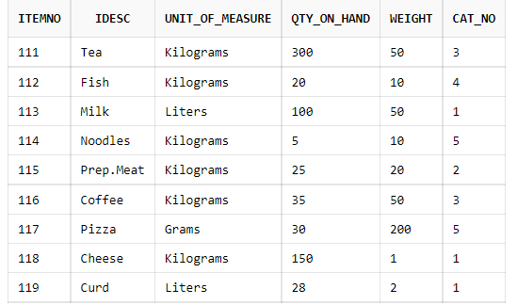

- Add a constraint to the ITEM table which will allow the QTY_ON_HAND to have values between 100 and 1000 only.

alter table item add constraint ck_qh check(qty_on_hand between 100 and 1000);

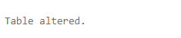

- Display how many items are there in each category.

select i.cat_no, c.cat_type, count(*) as No_OF_ITEMS from item i ,category c where i.cat_no = c.cat_no group by(i.cat_no,c.cat_type) order by(i.cat_no) ;

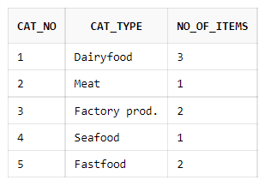

- Display the items in descending order of their weights.

select * from Item order by weight desc;

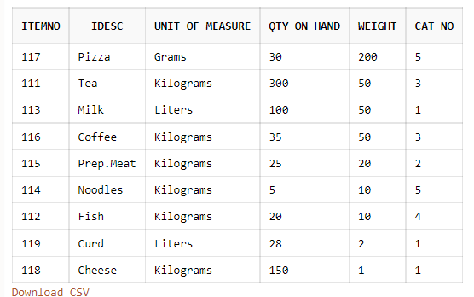

- Display categories which expire in the month of December.

select * from Category where (to_char(expiry_date,'Mon') = 'Dec');

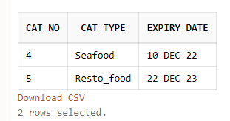

- Display items which have the same weight as that of ITEMNO 116.

select * from item where weight=(select weight from item where itemno =116);

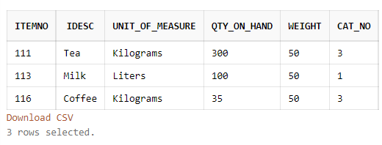

- Display items which do not have the alphabet ‘A’ or ‘T’ in their IDESC.

select * from item where upper(idesc) not like '%A%' and upper(idesc) not like '%T%';

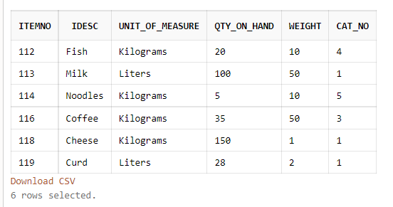

- Increase the size of the column IDESC by making it a variable length of 25 characters.

alter table item modify idesc varchar(25) ;
desc item

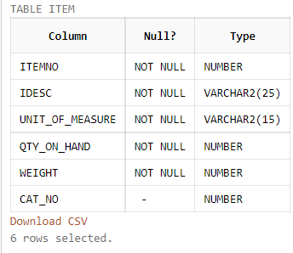

- Display the item details and the category details of items which have a UNIT_OF _MEASURE as Kilogram, Meters or Litres.

select i.idesc , c.cat_type from item i , category c
where i.cat_no=c.cat_no and upper(i.unit_of_measure)in('KILOGRAMS','LITERS','METERS');

